**LAB 2**

**OBJECTIVE:**

To perform various set operations in C programming.

## THEORY:

In Maths, sets are a collection of well-defined objects or elements. A set is represented by a capital letter symbol and the number of elements in the finite set is represented as the cardinal number of a set in a curly bracket {…}. For example, set A is a collection of all the natural numbers, such as A = {1,2,3,4,5,6,7,8,…..∞}.

In a set theory, there are three major types of operations performed on sets, such as: Union of sets (∪) Intersection of sets (∩) Difference of sets ( – )

## PROGRAM:

*#include<stdio.h>*

*void display(int arr[],int size){*

*int i;*

*for(i=0;i<size;i++)*

*printf("%d ",arr[i]);*

*printf("\n");*

*}*

*void Union(int a[],int b[],int m,int n){*

*int i,j,k;*

*int common[50],c_len=0,count=0;*

*int u[50];*

*for(i=0;i<m;i++)*

*u[count++] = a[i];*

*for(i=0;i<n;i++){*

*for(j=0;j<count;j++){*

*if(b[i] == u[j]) break;*

*}*

*if(j==count) u[count++] = b[i];*

*}*

*printf("\n A U B : ");*

*display(u,count);*

*}*

*void Intersection(int a[],int b[],int m,int n){*

*int i,j,count=0;*

*int intr[50];*

*for(i=0;i<m;i++){*

*for(j=0;j<n;j++){*

*if(a[i]==b[j]){*

*intr[count++]=a[i];*

*break;*

*} } }*

*printf("\n A n B : ");*

*display(intr,count);*

*}*

*void Difference(int a[], int b[],int m, int n){*

*int result[50],count = 0;*

*int isEqual = 0;*

*int i,j;*

*for(i=0;i<m;i++){*

*for(j=0;j<n;j++){*

*if(a[i] != b[j]){*

*isEqual = 0;*

*}else{*

*isEqual = 1;*

*break;*

*}*

*}*

*if(!isEqual) result[count++] = a[i];*

*}*

*printf("\n A - B : ");*

*display(result,count);*

*}*

*int main(){*

*int a[50],b[50];*

*int m,n,i,j;*

*printf("Enter the size of A and B:"); scanf("%d%d",&m,&n);*

*printf("\nEnter elements of A:\n");*

*for(i=0;i<m;i++)*

*scanf("%d",&a[i]);*

*printf("\nEnter elements of B:\n");*

*for(i=0;i<n;i++)*

*scanf("%d",&b[i]);*

*Intersection(a,b,m,n);*

*Union(a,b,m,n);*

*Difference(a,b,m,n);*

*return 0;*

*}*

Output:

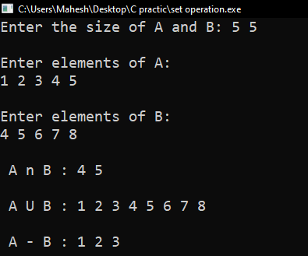

RESULTS AND DISCUSSION:

The experiment was successful to different set operatins in C programming. This program helps in C programming language.

CONCLUSION:

This laboratory exercise provided a hands-on experience in C program. Students gained practical knowledge of implementing algorithms in C programming and are now better equipped to undertake more complex programming tasks in the future.